**SILICON DIOXIDE (SiO2) DOP AND NANOPARTICLES**

***VERSION 1.0***

**Produced by: Natalia López Barbosa**

# OBJECTIVE

To suspend Silicon Dioxide (SiO2) nanoparticles in DOP.

# REQUIREMENTS

To follow this tutorial, it is necessary to have training in: centrifugation, pipetting, and use of a hotplate.

# REQUISITOS DE SOFTWARE

None.

# STEP BY STEP

## EXTRACTION AND CONCENTRATION OF SiO2 NANOPARTICLES

1. Place 12 1.5mL Eppendorf tubes in an Eppendorf rack.
2. Shake the container in which the SiO2 nanoparticle buffer is stored.
3. Using a micropipette, add 1mL of the SiO2 nanoparticle buffer to each of the Eppendorf tubes.
4. Close the lids of the Eppendorf tubes to prevent spills.
5. Place the 12 Eppendorf tubes inside the centrifuge.

***Note:*** If you wish to extract a smaller volume and use a lower number of Eppendorf tubes, they must be located in such a way that the centrifuge remains balanced. Figure 1 shows the correct way to position 4 Eppendorf tubes in the centrifuge*.*

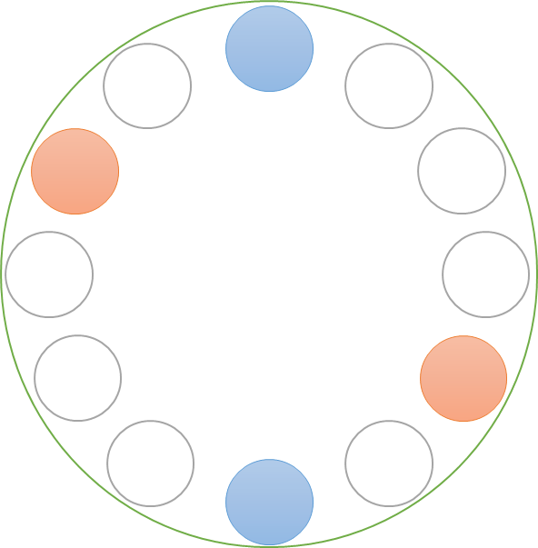

Figure 1. Location of 4 Eppendorf tubes inside the centrifuge.

1. Set the centrifuge to 14600 rpm for 20 minutes.
2. Close the centrifuge and start the program.
3. After 20 minutes, open the centrifuge and remove the Eppendorf tubes.

***Note:*** The Eppendorf tubes must remain upright at all times for the effect of centrifugation to remain in them. Keep the Eppendorf tubes closed and upright for at least 4 hours. This process increases the concentration of SiO2 nanoparticles in the lower half of the Eppendorf tubes by 23.44%.

1. Discard 500µL of the upper volume of each Eppendorf tube.

## SUSPENSION OF SiO2 NANOPARTICLES IN DOP

1. Use a 50mL Falcon tube and place the 6mL extracted in the previous procedure.
2. Fill the remaining volume of the Falcon tube with DOP.
3. Vigorously shake the Falcon tube for 1 hour. It is important to observe that the aqueous and DOP phases mix. Very small bubbles should form.
4. Pour the contents of the Falcon tube into a glass Beaker.
5. Place the glass on the hotplate and set it to 60°C.
6. Stir the solution for 30 minutes.
7. Turn off the hotplate.
8. Once the Beaker has cooled, remove it from the hotplate and place it in an area where it can remain static.
9. Wait for the aqueous phase to separate from the DOP. It should be located at the bottom of the Beaker.
10. Remove the non-aqueous phase to a container where it can be stored. This contains the DOP with the suspended SiO2 nanoparticles. Be careful not to remove the aqueous phase.
11. Discard the aqueous phase.

# CHANGE CONTROL

|  |  |  |  |
| --- | --- | --- | --- |
| **CHANGE DESCRIPTION** | **DATE** | **VERSION** | **APPROVED BY** |
|  |  |  |  |